Launch Amazon EC2 in a Non-Default Virtual Private Cloud

Alen Ovalles

Purpose

The purpose of this lab is to create a new private cloud (VPC) and deploy an Amazon EC2 instance in the network of the created VPC, not using a default VPC. Manually creating an Amazon VPC, creating and launching a web server using a t-2 micro Amazon EC2 instance, and deploy the created instance.

Process with Pictures

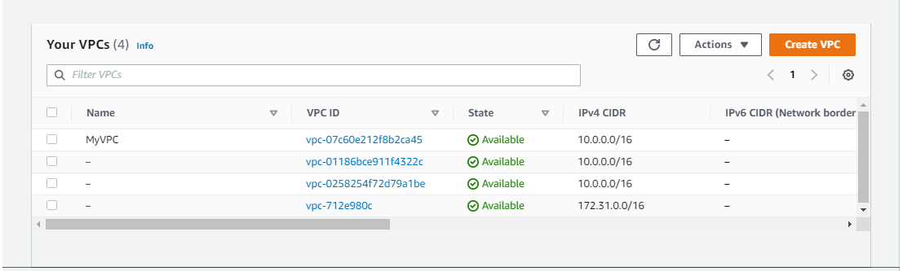

**Step 1:** Create a virtual private cloud

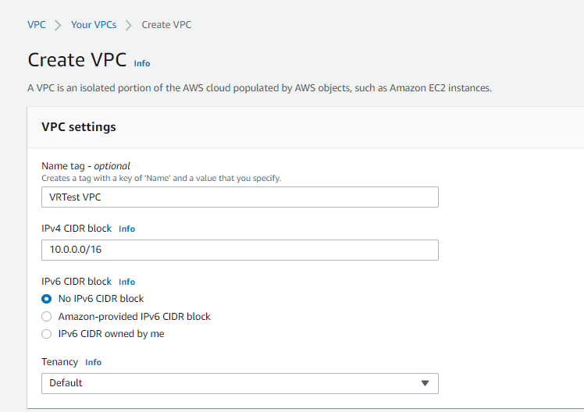

**Step 2:** Name: VRTest VPC | IPv4CIDR block: 10.0.0.0/16 | Tenancy: Default

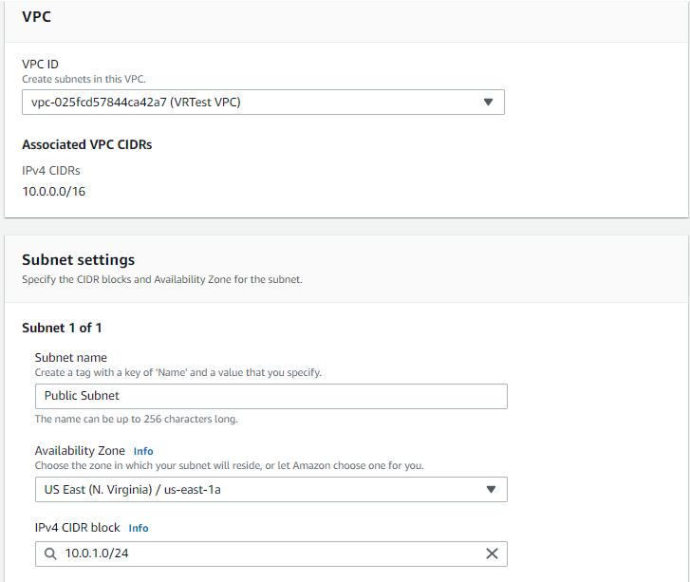

**Step 3:** Create a Public Subnet

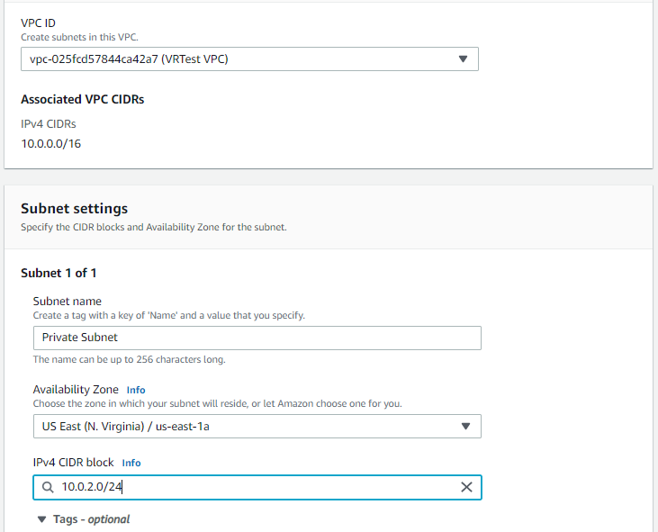

**Step 4:** Create a Private Subnet

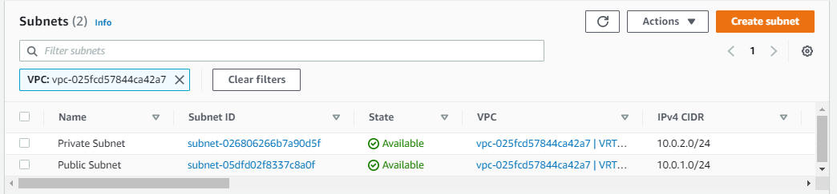

**Step 5:** Examine that the subnets are under the correct VPC

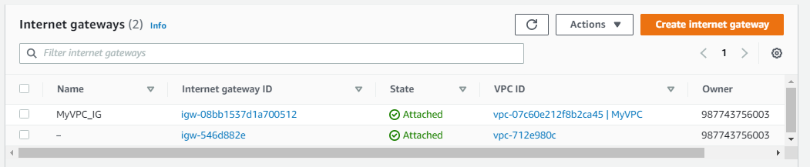

**Step 6:** Navigate to the Internet gateway tab

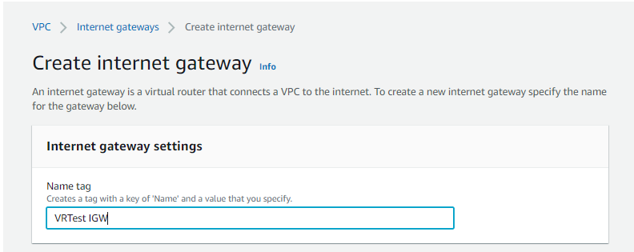

**Step 7:** Create an Internet gateway | Name: VRTest IGW

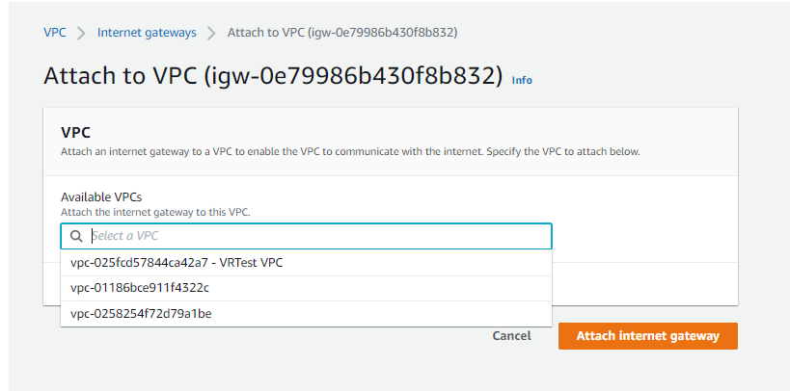

**Step 8:** Attach created VPC (VRTest VPC) to Internet gateway (VRTest IGW)

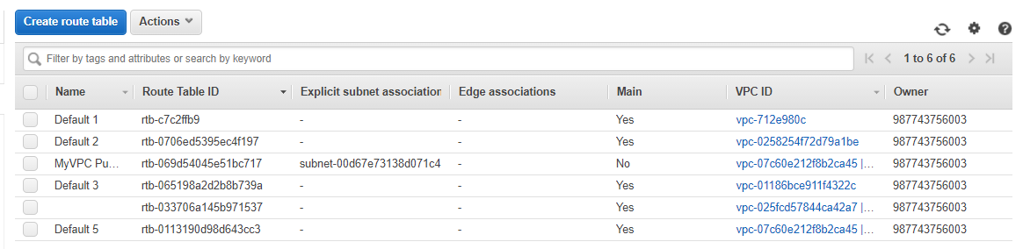

**Step 9:** Navigate to the route table tab

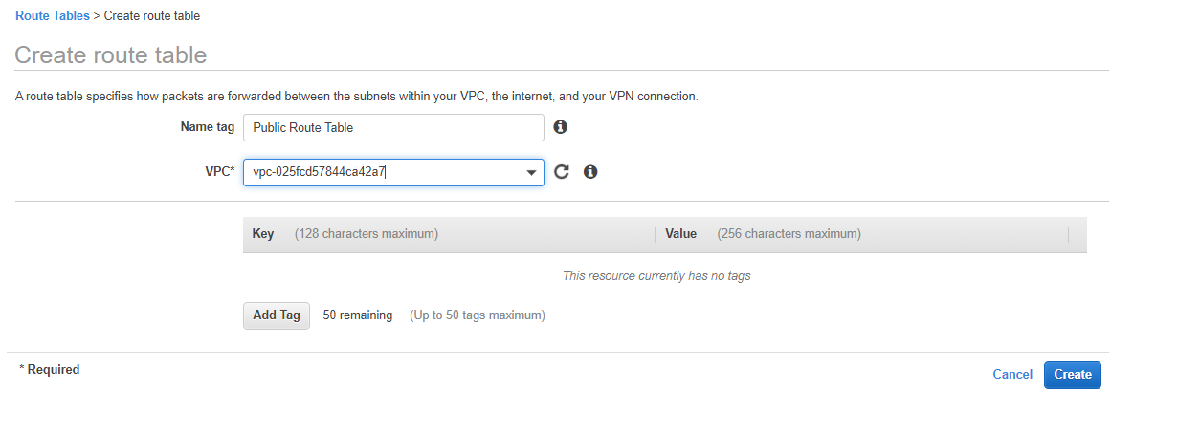

**Step 10:** Create a Public Route Table connected to VRTest VPC

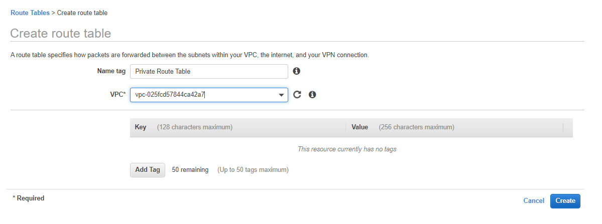

**Step 11:** Create a Private Route Table connected to VRTest VPC

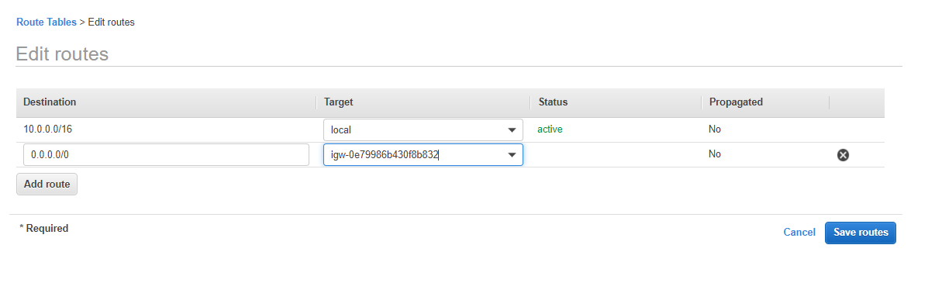

**Step 12:** Add routes to both the public and private routes of 0.0.0.0/0

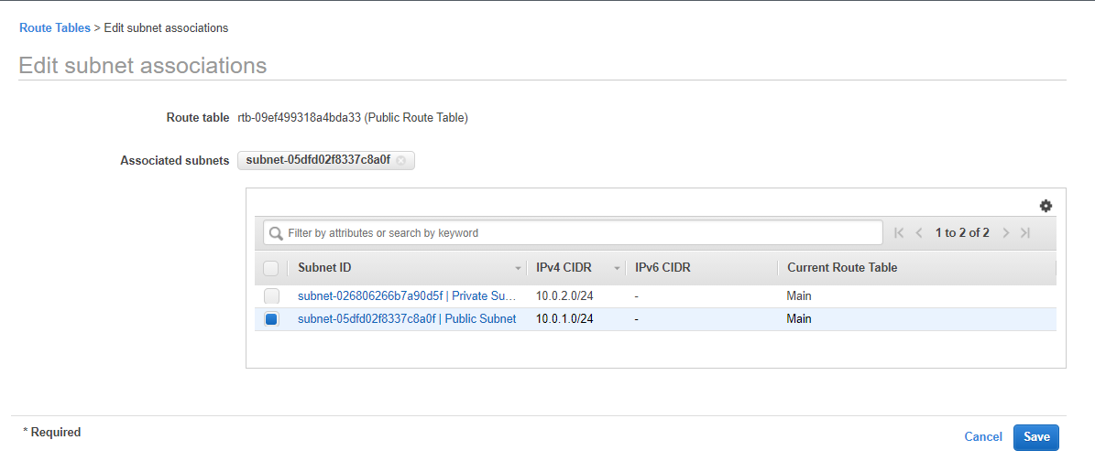

**Step 13:** Connect the Public Subnet to the Public Route Table

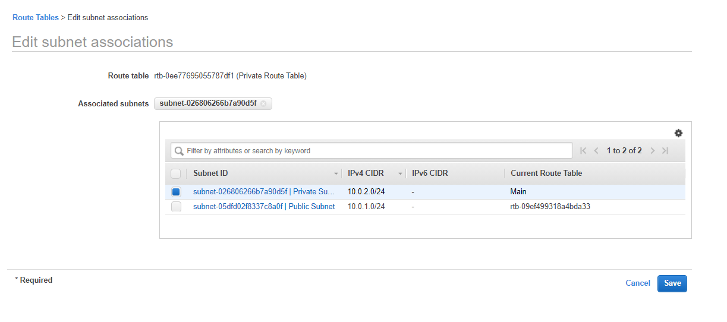

**Step 14:** Connect the Private Subnet to the Private Route Table

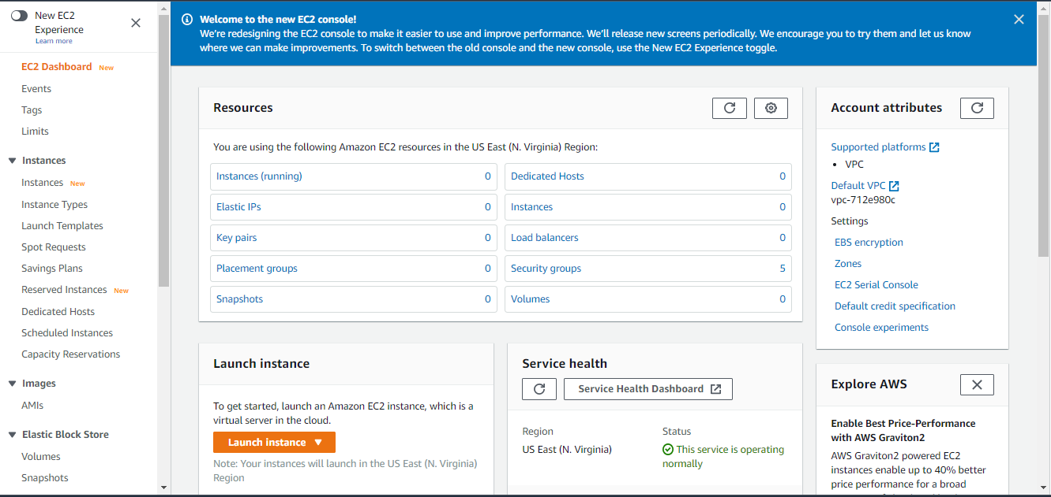

**Step 15:** Navigate to the EC2 Dashboard and locate Launch Instance (in Orange)

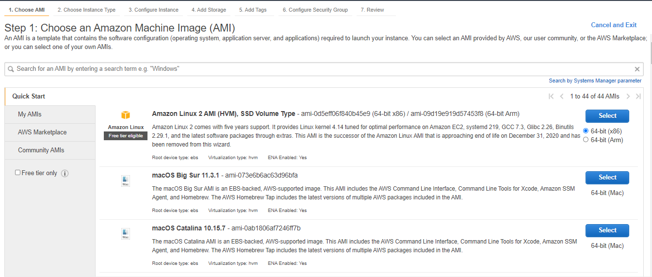

**Step 16:** Select the Amazon Linux 2 AMI (HVM)

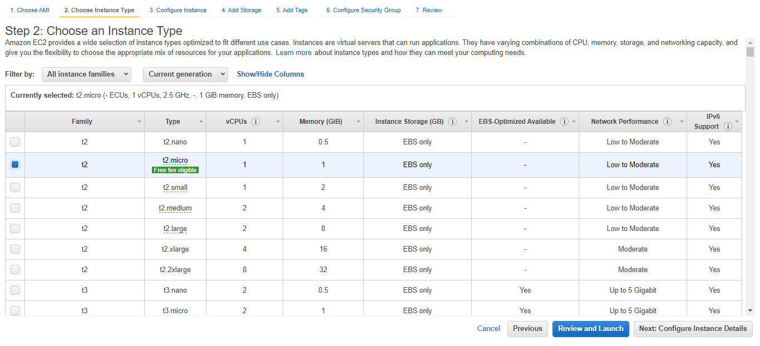

**Step 17:** Notice the variety of types; Select the t2.micro instance

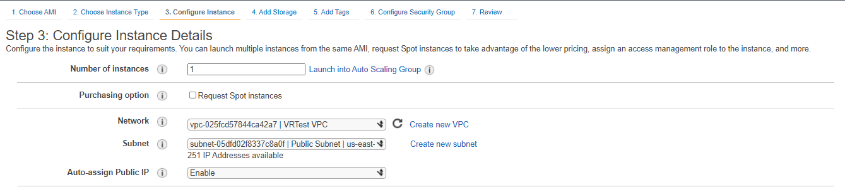

**Step 18:** Configure instance details | Network: VRTest VPC | Subnet: Public Subnet

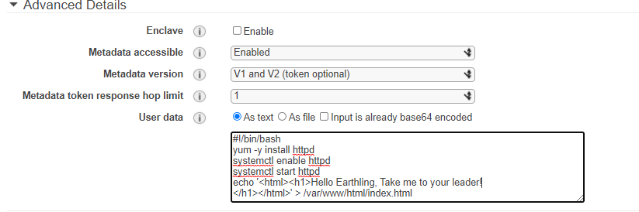

**Step 19:** Under Advanced Details in User Data insert bash script

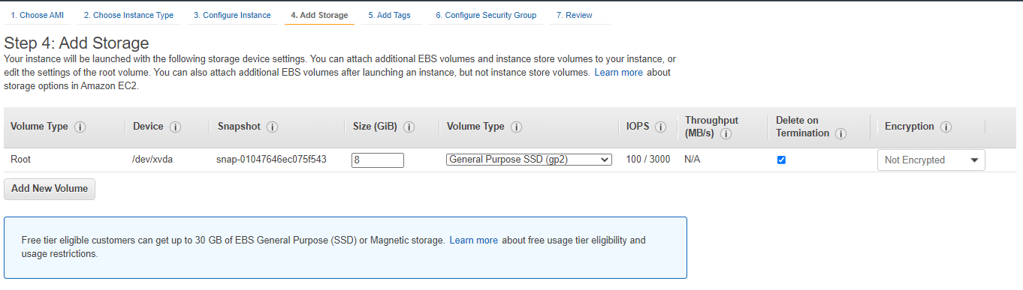

**Step 20:** Don’t need to change storage for this lab

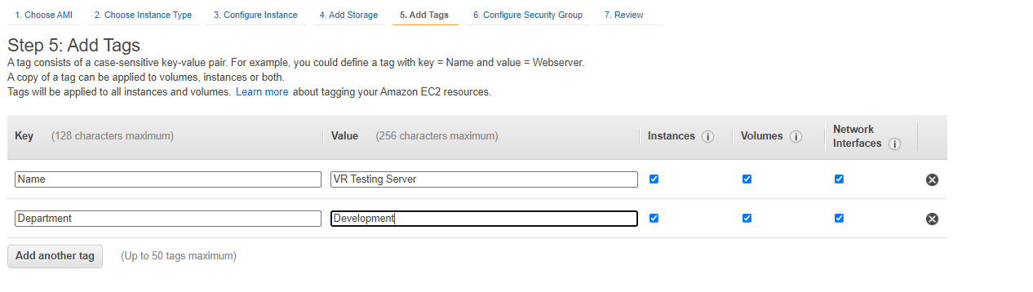

**Step 21:** Add tags | Key: Name, Value: VR Testing Server | Key: Department,

Value: Development

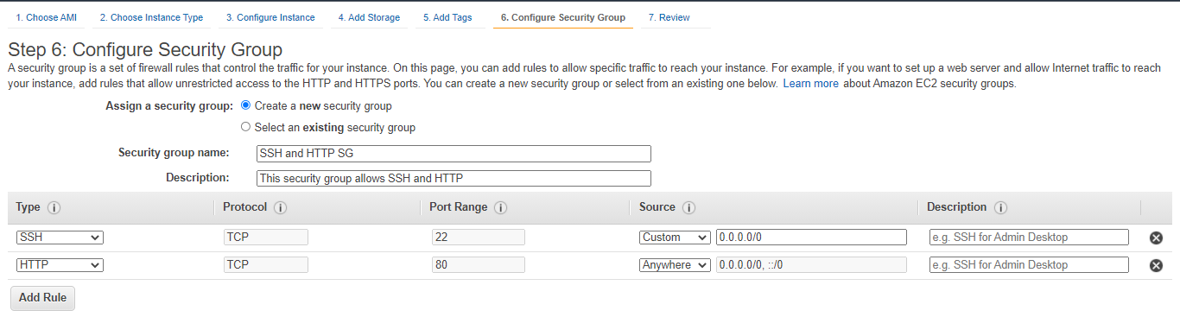

**Step 22:** Configure new Security Group | Security Group Name: SSH and HTTP SG |

Description: This security group allows for SSH and HTTP

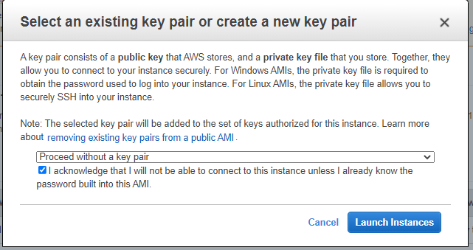

**Step 23:** Launch instance and proceed without a key pair

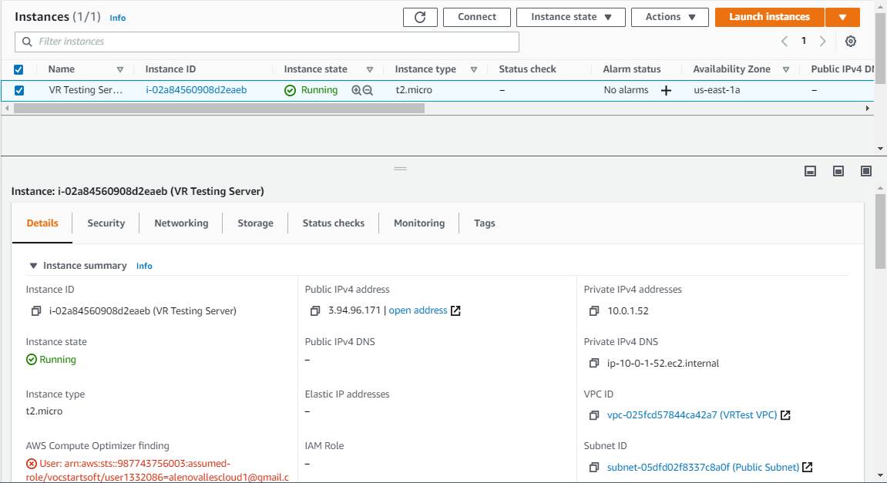

**Step 24:** Select VR Amazon EC2 server and copy IPv4 public ip address

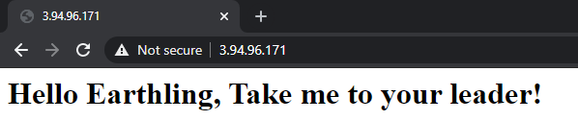

**Step 25:** Test public ip address | http://[ip address]

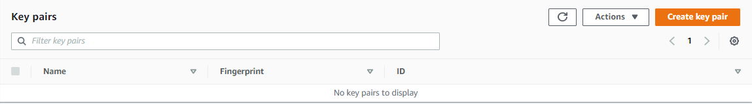

**Bonus Activity Step 1:** Navigate to the Amazon EC2 dashboard > Network and Security > Key Pairs

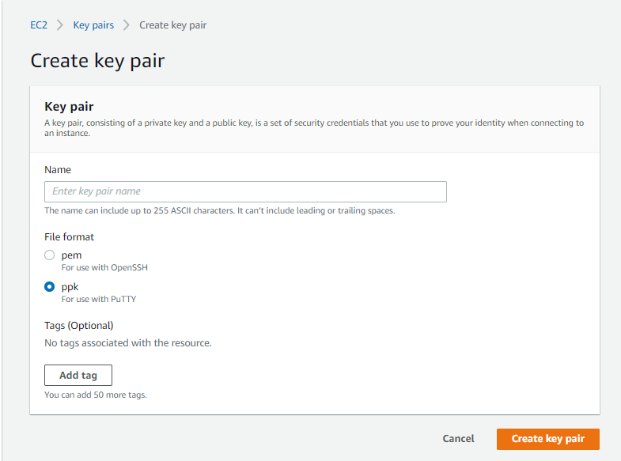

**Bonus Activity Step 2:** Notice two file formats can save a key pair; It’s unnecessary to create a key pair for this lab.

Problems

There was no problem in this lab due to it having instructions and steps from the first four past labs. There would be a problem if someone hasn’t done the first four labs before this one. The first lab had the user the basics about VPC, subnets, route table, and the internet gateway. Secondly, building a static website with S3. Thirdly, had the user configure an Amazon EC2 instance and finally the fourth had the user using Amazon VPC Wizard.

Test Your Knowledge

What is a default VPC and why would you use it? Automatically create for an AWS account and would use it to quickly deploy resources without think about the underlying network.

When creating your public subnet, what must you do to make the subnet public? Having and 0.0.0.0/0 available route.

What role does the route table play in a VPC? To control where network traffic is directed.

If you don’t specify the subnet and availability zone when creating an Amazon EC2 instance, what happens? Works on used availability zone when creating the EC2 instance.

What is the auto-assign public IP default setting? Requests a public Ipv4 address for all instances launched into the selected subnet.

What will happen if you do not adjust the auto-assign public IP setting to “enable”? Will start without an assigned ip until manually assigned one.

Describe what a security group is and why it’s important? Acts like a virtual firewall for the EC2 instance to control incoming and outgoing traffic.

Why did you create a private subnet? When would you use this? Used to provide devices that don’t need a connection to the internet to communicate with other devices on a network without being directly expose to the public internet.

What is the purpose of the internet gateway? What’s the result if you don’t create and attach an internet gateway to your VPC? To provide a target for the VPC route table for internet routable traffic and to perform NAT (Network Address Translation) for instances that have been assigned to public Ipv4 addresses. The VPC can’t connect to the internet if a internet gateway isn’t created and connected.